Game Design Document

Fill up the following document

1. Write the title of your project.

Super Mario

1. What is the goal of the game?

To save the princess

1. Write a brief story of your game.

Mario will spawn at a place where he will fight against monsters

And obstacles in his path . At the end mario will reach the place

Where he will save his princess from the biggest monster.

1. Which are the playing characters of this game?

* Playing characters are the ones who respond to the user based on the input from the user.
* Cars, monkeys, dinos, wizards, etc., are the playing characters in the game.

|  |  |  |
| --- | --- | --- |
| Number | Character Name | What can this character do? |
| 1 | mario | He can jump and throw fireBalls |
| 2 |  |  |
| 3 |  |  |
| 4 |  |  |
| 5 |  |  |
| 6 |  |  |
| 7 |  |  |
| 8 |  |  |

1. Which are the Non-Playing Characters of this game?

* Non-Playing characters are the ones that don't have an action or behavior when the user interacts with the game.
* Hurdles, stones, bananas, coins, etc., are non-playing characters in the game.

|  |  |  |
| --- | --- | --- |
| Number | Character Name | What can this character do? |
| 1 | coin | Mario can collect these coins . |
| 2 | Crabs | They stop mario from reaching the king. |
| 3 | snails | They also prevent mario from reaching the king |
| 4 |  |  |
| 5 |  |  |
| 6 |  |  |
| 7 |  |  |
| 8 |  |  |

Draw your imagination of this game. What does this game look like?

* Draw the game either on your computer or on paper.
* Add images of the game scenes to show each of the playing and non-playing characters at least once.

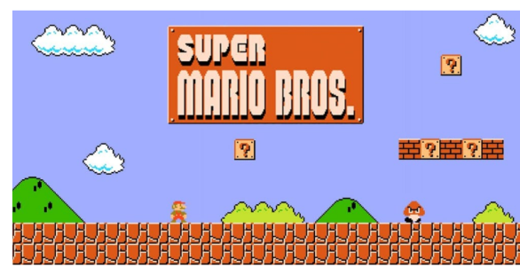

How do you plan to make your game engaging?

By adding various obstacles and power in the game and making it balanced like not

To hard and not to easy